**MA4605 2015 Lecture 6A**

* Use of regression in clinical sciences (5:1,5:2)
* Limits of detection (5:7)

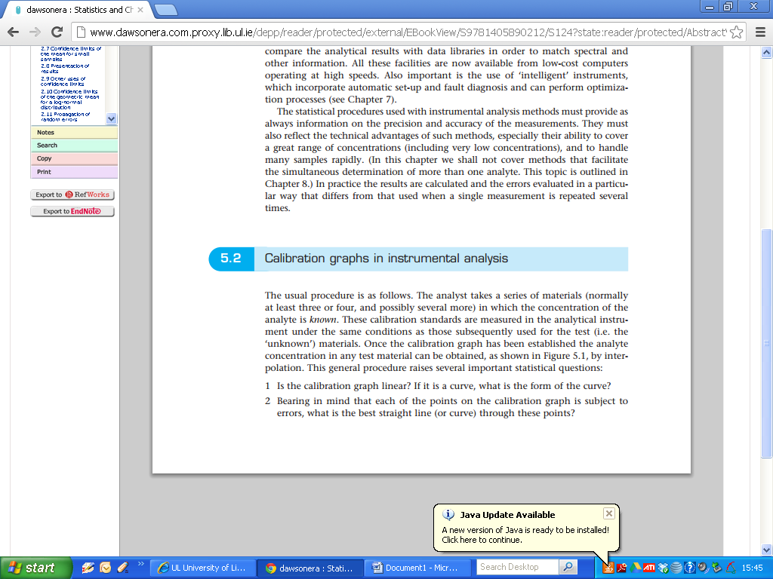

The usual procedure is as follows, the analyst takes a series of materials (normally at least three or four, and possibly several more) in which the concentration of the analyte is known. These calibration standards are measured in the analytical instrument under the same conditions as those subsequently used for the test (i.e. the 'unknown’) materials.

Once the calibration graph has been established the analyte concentration in any test material can be obtained by interpolation.

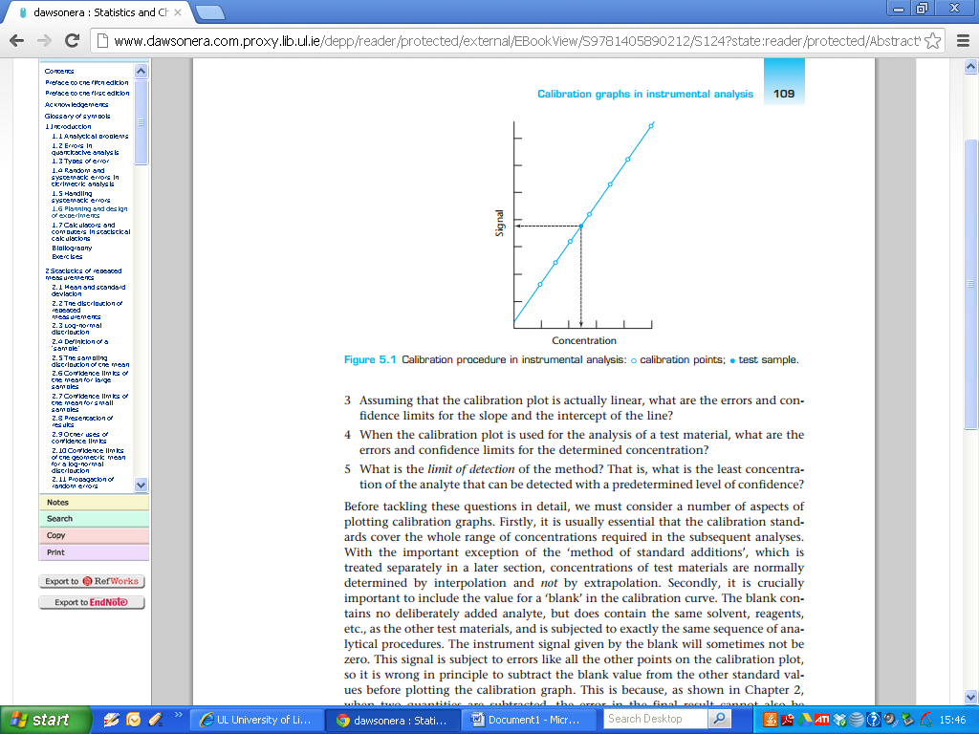

This general procedure raises several important statistical questions:

1 Is the calibration graph linear? lf it is a curve, what is the form of the curve?

2 Bearing in mind that each of the points on the calibration graph is subject to errors, what is the best straight line (or curve) through these points?

3 Assuming that the calibration plot is actually linear, what are the errors and conﬁdence limits for the slope and the intercept of the line?

4 When the calibration plot is used for the analysis of a test material, what are the errors and conﬁdence limits for the determined concentration?

S What is the ***limit of detection*** of the method? That is, what is the least concentration of the analyte that can be detected with a predetermined level of ‘confidence’

Before tackling these questions in detail, we must consider a number of aspects of plotting calibration graphs.

Firstly, it is usually essential that the calibration standards cover the whole range of concentrations required in the subsequent analyses. With the important exception of the ‘method of standard additions’ (next section ) concentrations of test materials are normally determined by interpolation and not by extrapolation.

**Blank**

Secondly, it is crucially important to include the value for a ‘blank’ in the calibration curve.

**Important:** The blank contains ***no deliberately added*** analyte, but does contain the same solvent, reagents,etc., as the other test materials, and is subjected to exactly the same sequence of analytical procedures.

The instrument signal given by the blank will sometimes not be zero. This signal is subject to errors like all the other points on the calibration plot, so it is wrong in principle to subtract the blank value from the other standard values before plotting the calibration graph.

This is because when two quantities are subtracted, the error in the ﬁnal result cannot also be obtained by simple subtraction. Subtracting the blank value from each of the other instrument signals before plotting the graph thus gives incorrect information on the errors in the calibration process.

It should be noted that the calibration curve is always plotted with the instrument signals on the vertical (y) axis and the standard concentrations on the horizontal (x) axis.

**Important:** This is because many procedures assume that all the errors are in ***the fitted values*** and that the standard concentrations (x-values) are error-free.

**5.7 Limits of detection**

**Important:** One of the principal benefits of using instrumental methods of analysis is that they are capable of ***detecting and determining trace and ultra-trace quantities of analytes***.

These benefits have led to the appreciation of the importance of very low concentrations of many materials, for example in biological and environmental samples, and thus to the development of many further techniques in which lower limits of detection are a major criterion of successful application. It is therefore evident that statistical methods for assessing and comparing limits of detection are of importance.

***Important: In general terms, the limit of detection of an analyte may be described as that concentration which gives an instrument signal (y) significantly different from the 'blank' or 'background’ signal.***

This description gives the analyst a good deal of freedom to decide the exact definition of the limit of detection, based on a suitable interpretation of the phrase 'significantly different'.

|  |
| --- |
| The Blank Signal is the expected analyte concentration expected to be found when replicates of a blank sample containing no analyte are tested ( related to the regression intercept). |

**Formal Definition of Limits of Detection**

There is still no full agreement between researchers, publishers, and professional and statutory bodies on this point. But there is an increasing trend to define the limit of detection as the analyte concentration giving a signal equal to the blank signal, ***yB*** , plus three standard deviations of the blank, ***sB***:

(Recall: Confidence intervals for fitted values)

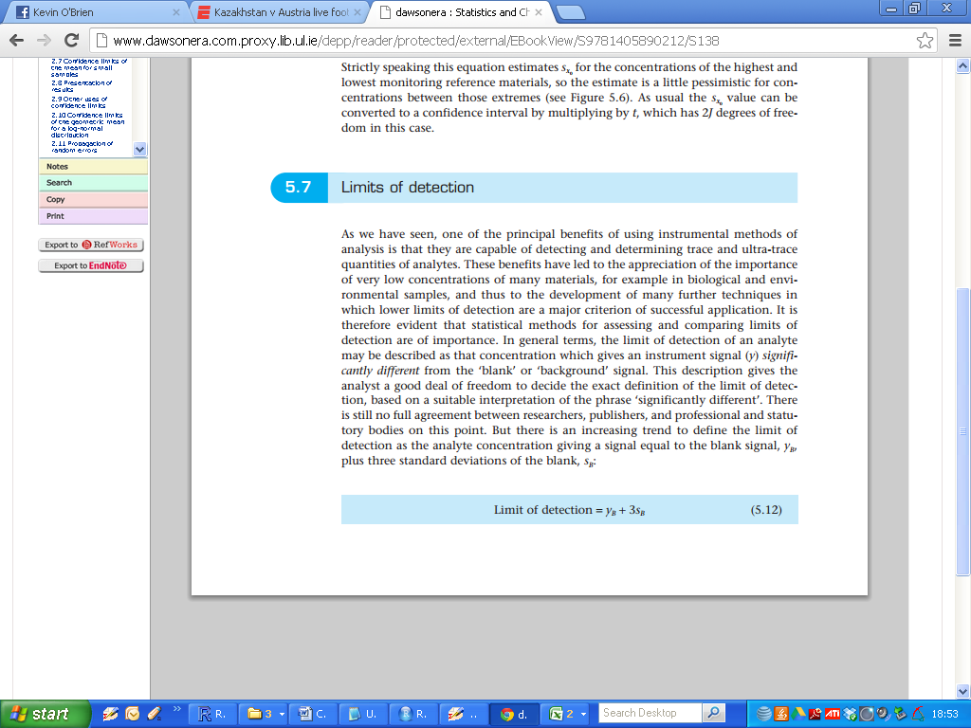

(Remark: There are other definitions on Limits of Detection)

|  |
| --- |
| The LoD is the lowest analyte concentration likely to be reliably distinguished from the blank and at which detection is feasible. |

The significance of this last definition is illustrated in more detail in Figure 5.7.

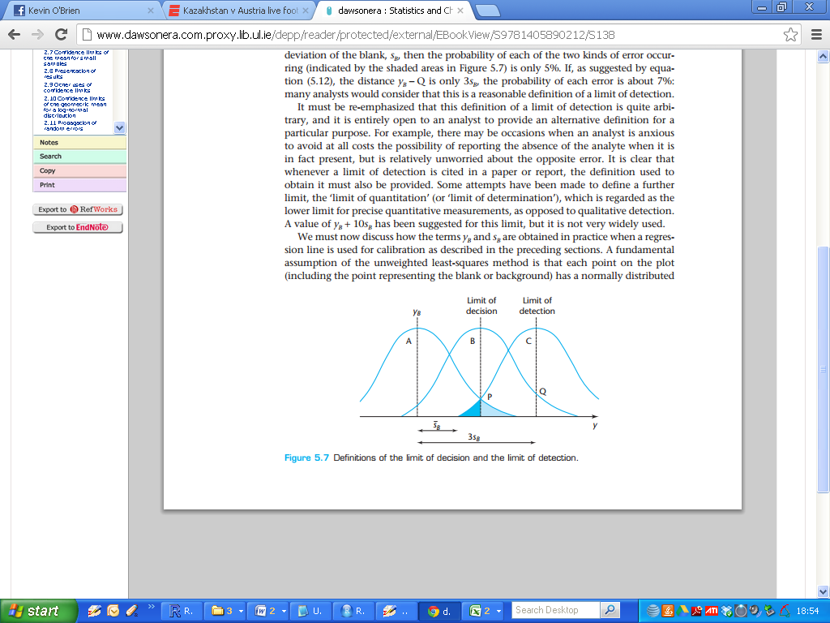

An analyst studying trace concentrations is confronted with two problems: it is important to avoid claiming the presence of the analyte when it is actually absent, but it is equally important to avoid reporting that the analyte is absent when it is in fact present.

(The situation is analogous to the occurrence of Type l and Type ll errors in significance tests, i.e. False Positives etc)

(***IMPORTANT***) there may be occasions when an analyst is anxious to avoid at all costs the possibility of reporting the absence of the analyte when it is in fact present, but is relatively unworried about the opposite error. It is clear that whenever a limit of detection is cited in a paper or report, the definition used to obtain it must also be provided

**Limits of Determination ( not examinable )**

Some attempts have been made to define a further limit, the ‘limit of quantitation' (or ‘limit of determination'), which is regarded as the lower limit for precise quantitative measurements, as opposed to qualitative detection.

A value of yB + 10 sB , has been suggested for this limit, but it is not very widely used.

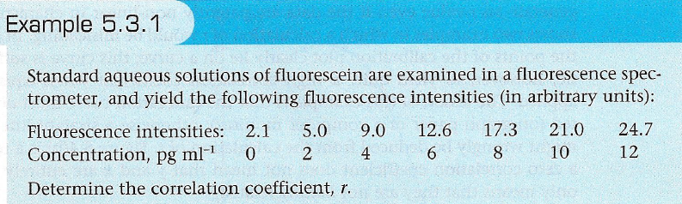

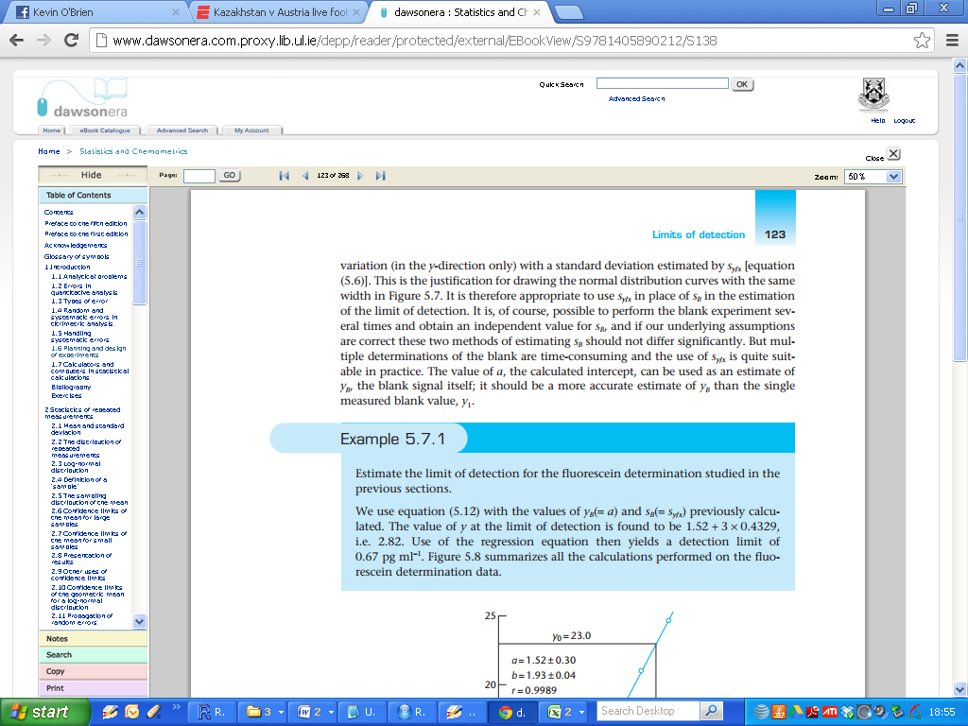

|  |
| --- |
| > summary(fit)  Call:  lm(formula = Int ~ Conc)  Residuals:  1 2 3 4 5 6 7  0.58214 -0.37857 -0.23929 -0.50000 0.33929 0.17857 0.01786  Coefficients:  Estimate Std. Error t value Pr(>|t|)  (Intercept) 1.5179 0.2949 5.146 0.00363 **  Conc 1.9304 0.0409 47.197 8.07e-08 ***  ---  Signif. codes: 0 ‘***’ 0.001 ‘**’ 0.01 ‘*’ 0.05 ‘.’ 0.1 ‘ ’ 1  Residual standard error: 0.4328 on 5 degrees of freedom  Multiple R-squared: 0.9978, Adjusted R-squared: 0.9973  F-statistic: 2228 on 1 and 5 DF, p-value: 8.066e-08 |

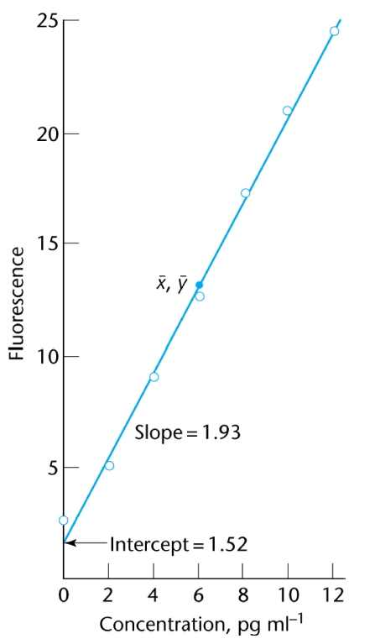

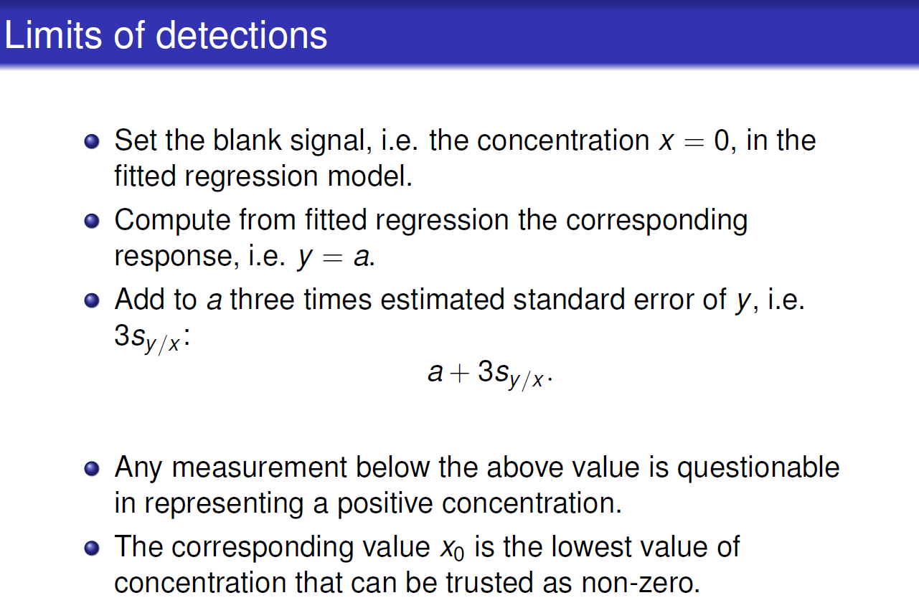

*(Remark: In this graphic, the intercept estimate is denoted “a” rather than “b0”)*

*( I will use Sb as the notation for standard error for Y )*

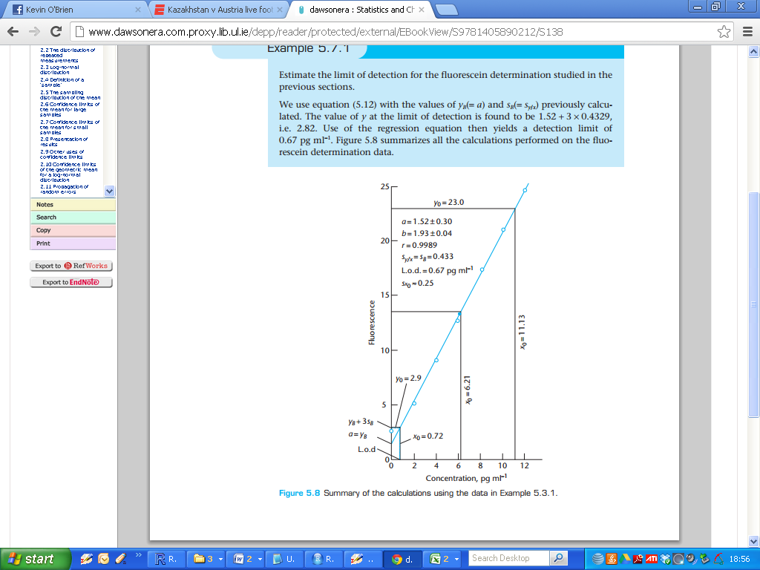

Intercept:

**b0 = 1.52**

Limit of detection (in terms of signal)

**b0 + 3Sb = 1.52 + (3 x 0.433) = 2.819**

What value of X (i.e. concentration) yields a signal of 2.819?

**1.5179 + (1.9304 x 0.674) = 2.819**

Answer: 0.674 units